IICS Import and Export Deployment Playbook

Table of Contents

Introduction 3

Exporting Objects from SOURCE Environment 3

Load Control Assets Export (1-6) 4

EDW Assets: Packet 1 4

EDW Assets: Packet 2 6

EDW Assets: Packet 3 7

EDW Assets: Packet 4 8

EDW Assets: Packet 5 9

EDW Assets: Packet 6 10

Import Steps 11

Load Control Assets Import (1-6) 12

EDW Assets: Packet 1 12

EDW Assets: Packet 2 14

EDW Assets: Packet 3 16

EDW Assets: Packet 4 18

EDW Assets: Packet 5 20

EDW Assets: Packet 6 23

Control-M IICS Integration 25

Connections Deployment on IICS 25

Connections Step Following 26

Connection Settings Setup 26

Deployment of agent files (i.e, DEV to QA) 28

Introduction 29

Step 1 29

Step 2 30

Step 3 31

SnowSQL 32

# Introduction

* Asset Source Sub-Org: I.e., Development
* Destination Sub-Org: I.e., QA / Landing Zone

<https://usw1.dm1-us.informaticacloud.com/>

The IICS Assets that need to be migrated from SOURCE Org to TARGET Org are the following:

* **Packet 1:** Load Control Assets
* **Packet 2:** EDW Assets from Taskflow01 - Taskflow05
* **Packet 3:** EDW Assets from Taskflow06 - Taskflow10
* **Packet 4:** EDW Assets from Taskflow11 - Taskflow15
* **Packet 5:** EDW Assets from Taskflow16 - Taskflow20
* **Packet 6:** EDW Assets from Taskflow21 - Taskflow25

# Exporting Objects from SOURCE Environment

## Load Control Assets Export (1-6)

### EDW Assets: Packet 1

1. **Select Packet 1 Objects**
   1. TSKF_EDW_INITIAL_SETUP_LOAD_CTL_2
   2. TSKF_EDW_END_LOAD_CTL_5
   3. m_LOAD_PC_DAC_PARAMETERS_TO_IICS_SNOWFLAKE_PARAMETERS

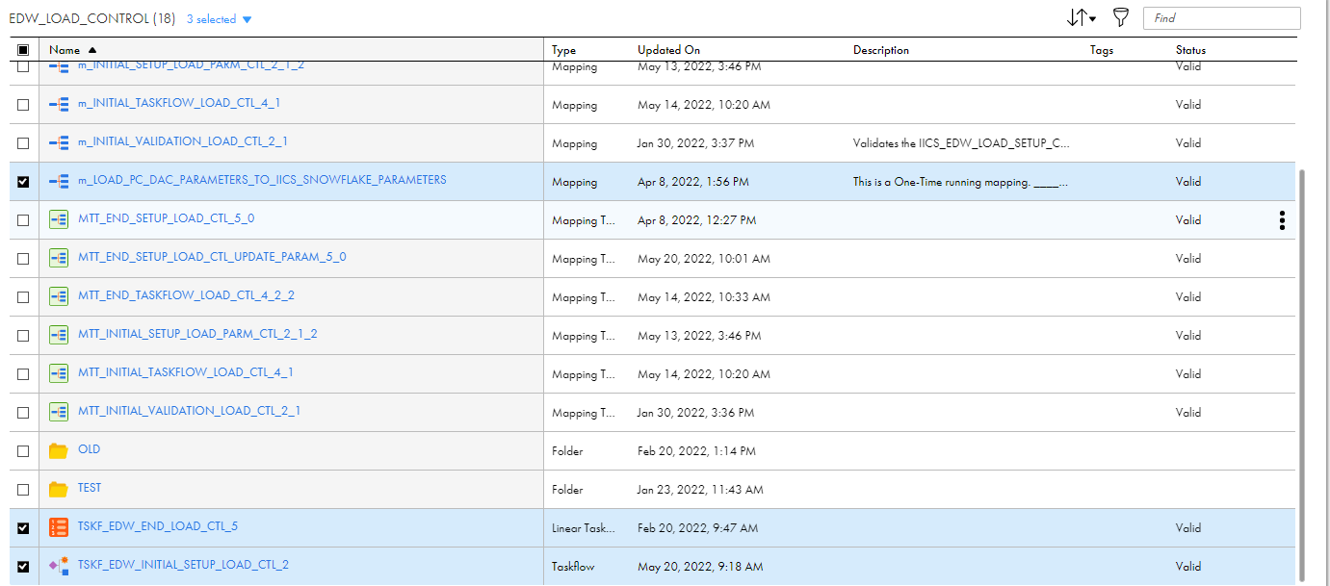

1. **Export Objects and give (optionally) a suffix name in the job that identifies the PACKET and make sure to include all the selected dependences by checking the option by checking the option as shown:**

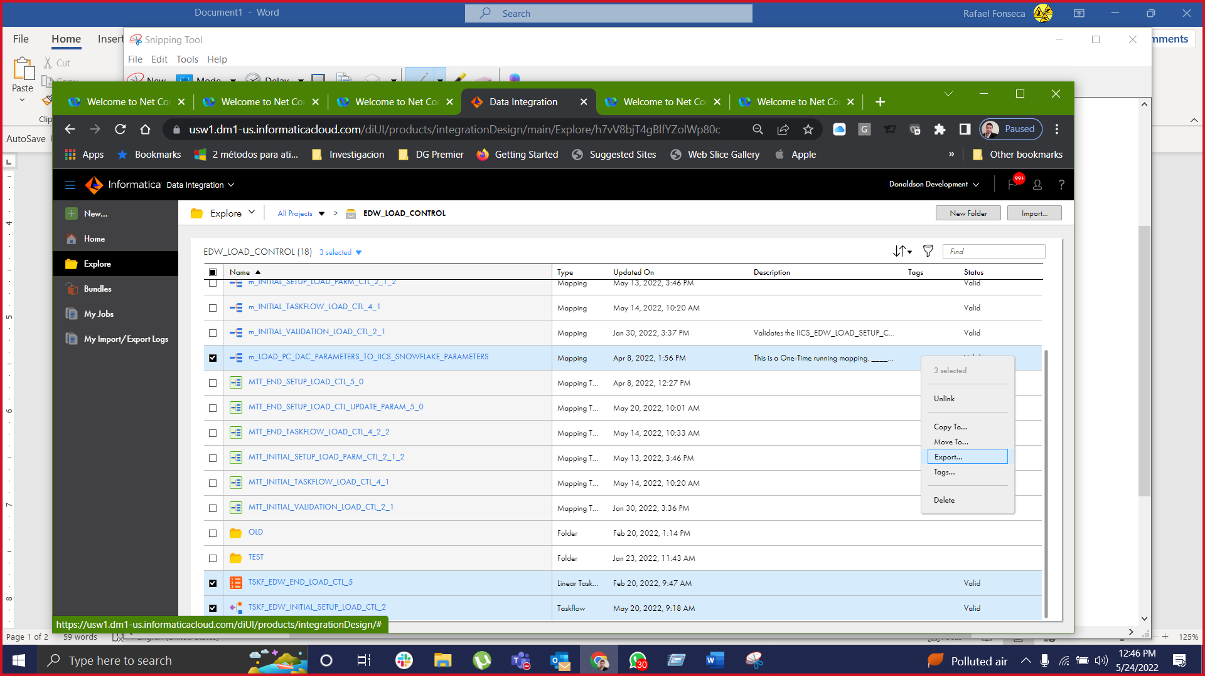

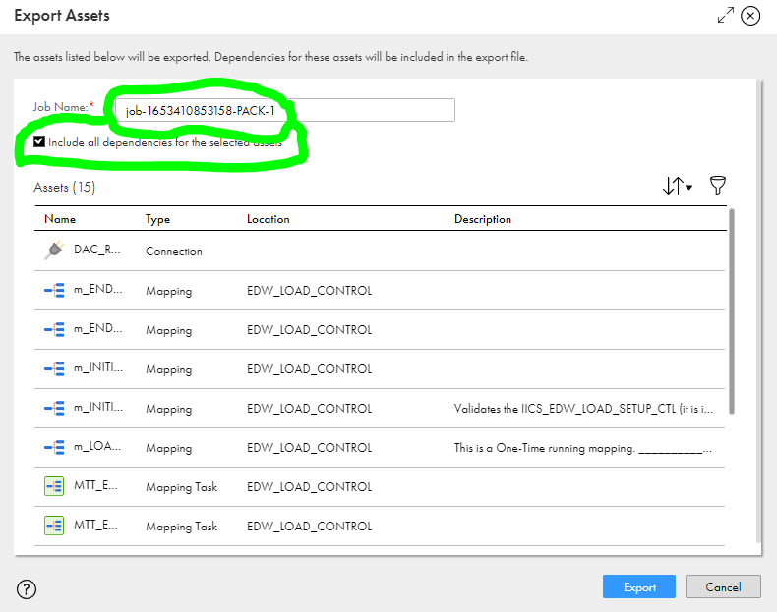

1. **In the My Import/Export Jobs page go to Export tab and download the packet related to the asset export (See A/B/C in the screenshot).**

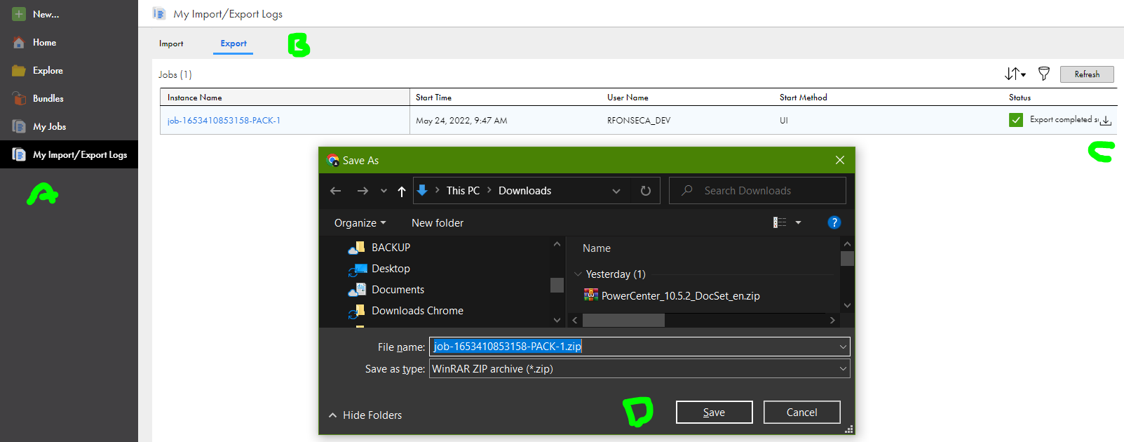

### EDW Assets: Packet 2

1. **Select Packet 2 Objects**
   1. Taskflow01
   2. Taskflow02
   3. Taskflow03
   4. Taskflow04
   5. Taskflow05

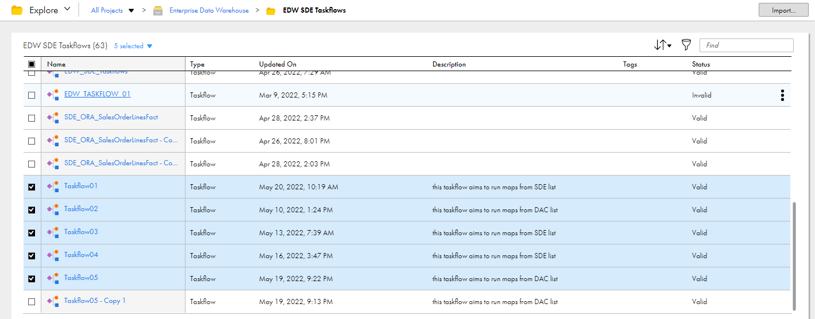

1. **Export Objects and give (optionally) a suffix name in the job that identifies the PACKET and make sure to include all the selected dependences by checking the option as shown**

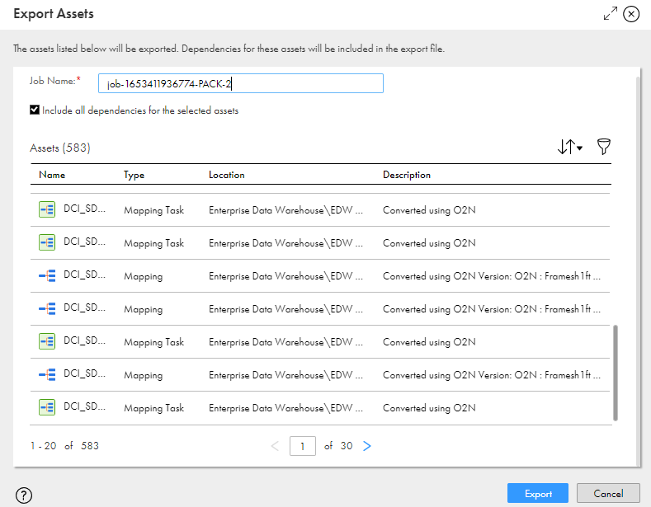

1. **In the My Import/Export Jobs page go to Export tab and download the packet related to the asset export.**

### EDW Assets: Packet 3

1. **Select Packet 3 Objects**
   1. Taskflow06
   2. Taskflow07
   3. Taskflow08
   4. Taskflow09
   5. Taskflow10

1. **Export Objects and give (optionally) a suffix name in the job that identifies the PACKET and make sure to include all the selected dependences by checking the option as shown:**

1. **In the My Import/Export Jobs page go to Export tab and download the packet related to the asset export.**

### EDW Assets: Packet 4

1. **Select Packet 4 Objects**
   1. Taskflow11
   2. Taskflow12
   3. Taskflow13
   4. Taskflow14
   5. Taskflow15

1. **Export Objects and give (optionally) a suffix name in the job that identifies the PACKET**

1. **In the My Import/Export Jobs page go to Export tab and download the packet related to the asset export.**

### EDW Assets: Packet 5

1. **Select Packet 5 Objects**
   1. Taskflow16
   2. Taskflow17
   3. Taskflow18
   4. Taskflow19
   5. Taskflow20

1. **Export Objects and give (optionally) a suffix name in the job that identifies the PACKET**



1. **In the My Import/Export Jobs page go to Export tab and download the packet related to the asset export.**

### EDW Assets: Packet 6

1. **Select Packet 6 Objects**
   1. Taskflow21
   2. Taskflow22
   3. Taskflow23
   4. Taskflow24
   5. Taskflow25

1. **Export Objects and give (optionally) a suffix name in the job that identifies the PACKET and make sure to include all the selected dependences by checking the option as shown:**

1. **In the My Import/Export Jobs page go to Export tab and download the packet related to the asset export.**

# Import Steps

Importing Objects to DESTINATION Environment

## Load Control Assets Import (1-6)

### EDW Assets: Packet 1

1. **Click on Import button and select the Packet 1 export file**

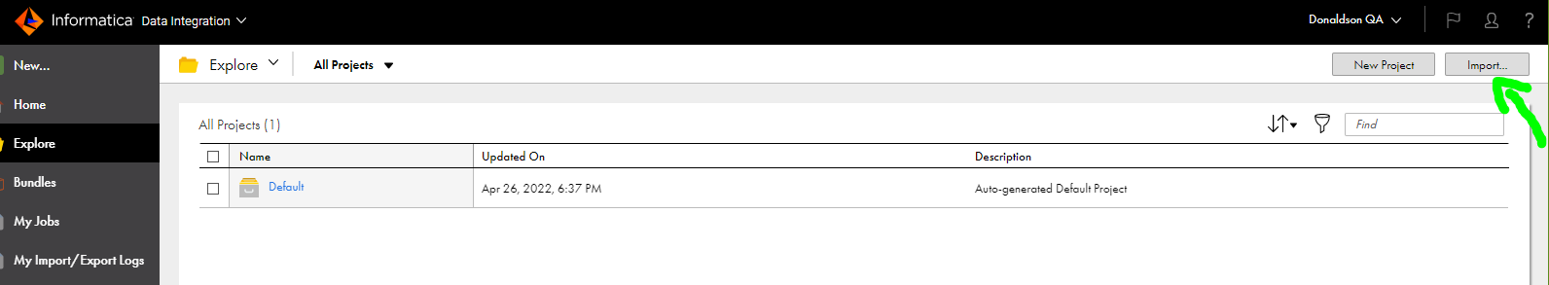

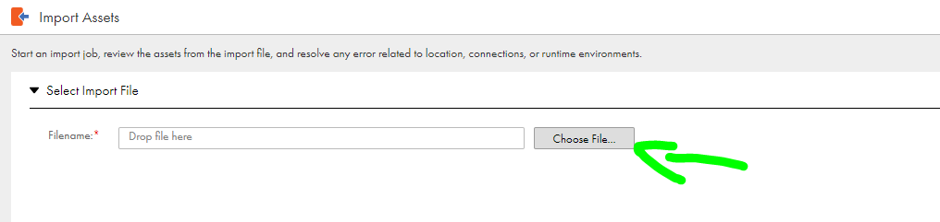

1. **Make sure that the following items:**
   1. Overwrite existing assets, excluding connections and runtime environments (enabled by default).

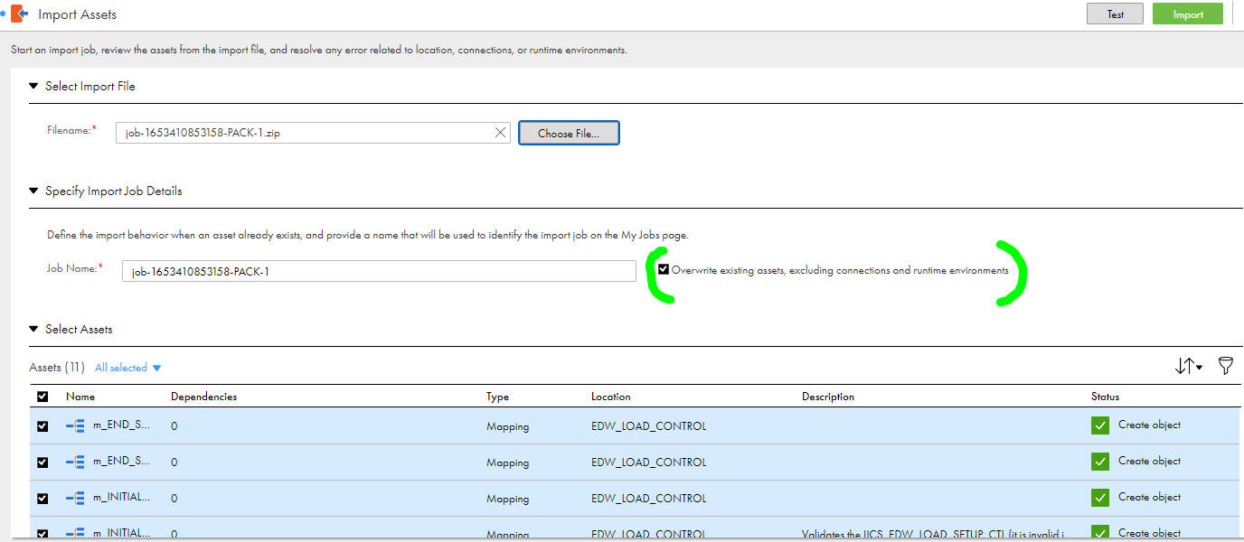

* 1. The destination location reflects the source (Project).
  2. Connections will reflect the source.

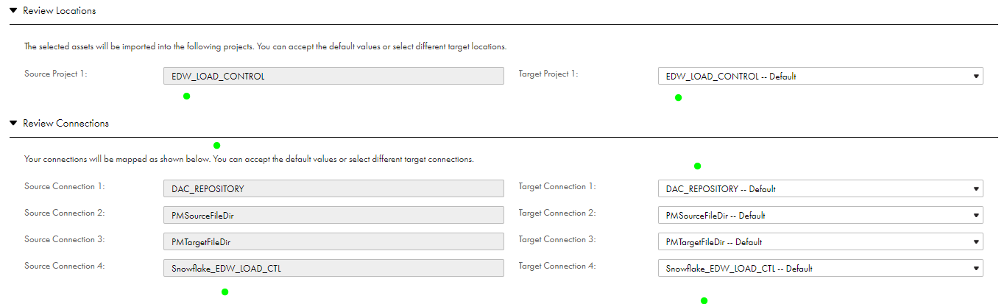

* 1. Change the Runtime Environment (must be QA environment) to reflect the environment in which the ETLs will run.
  2. Enable the checkbox Publish Taskflow(s) after import (not enabled by default).

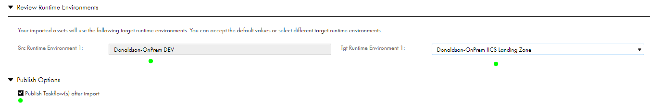

1. **Click in the Import button to start the import job.**

### EDW Assets: Packet 2

1. **Click on Import button and select the Packet 2 export file**





1. **Make sure that the following items:**
   1. Overwrite existing assets, excluding connections and runtime environments (enabled by default).

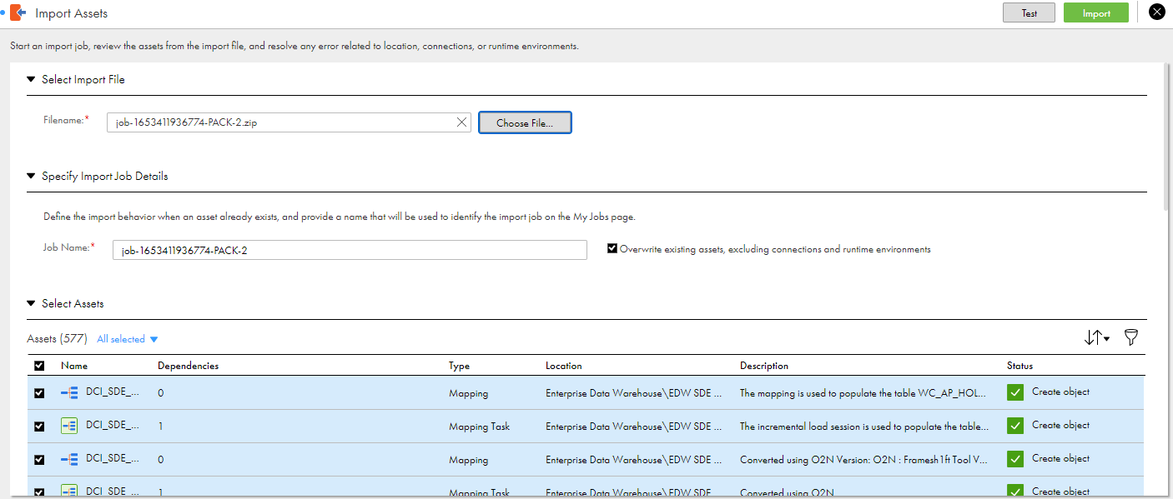

* 1. The destination location reflects the source (Project).
  2. Connections will reflect the source.

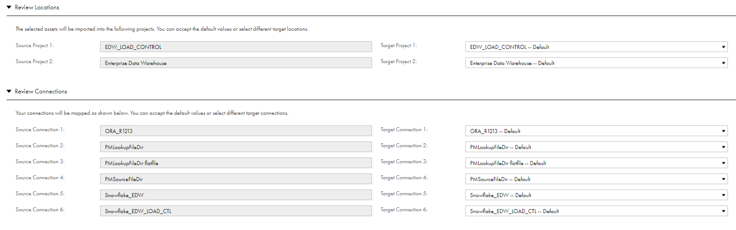

* 1. Change the Runtime Environment (must be QA environment) to reflect the environment in which the ETLs will run.
  2. Enable the checkbox Publish Taskflow(s) after import (not enabled by default).



1. **Click in the Import button to start the import job.**

### EDW Assets: Packet 3

1. **Click on Import button and select the Packet 3 export file**





1. **Make sure that the following items:**
   1. Overwrite existing assets, excluding connections and runtime environments (enabled by default).

* 1. The destination location reflects the source (Project).
  2. Connections will reflect the source.

* 1. Change the Runtime Environment (must be QA environment) to reflect the environment in which the ETLs will run.
  2. Enable the checkbox Publish Taskflow(s) after import (not enabled by default).



1. **Click in the Import button to start the import job.**

### EDW Assets: Packet 4

1. **Click on Import button and select the Packet 4 export file**





1. **Make sure that the following items:**
   1. Overwrite existing assets, excluding connections and runtime environments (enabled by default).

* 1. The destination location reflects the source (Project).
  2. Connections will reflect the source.

* 1. Change the Runtime Environment (must be QA environment) to reflect the environment in which the ETLs will run.
  2. Enable the checkbox Publish Taskflow(s) after import (not enabled by default).



1. **Click in the Import button to start the import job.**

### EDW Assets: Packet 5

1. **Click on Import button and select the Packet 5 export file**





1. **Make sure that the following items:**
   1. Overwrite existing assets, excluding connections and runtime environments (enabled by default).

* 1. The destination location reflects the source (Project).
  2. Connections will reflect the source.

* 1. Change the Runtime Environment (must be QA environment) to reflect the environment in which the ETLs will run.
  2. Enable the checkbox Publish Taskflow(s) after import (not enabled by default).



1. **Click in the Import button to start the import job.**

### EDW Assets: Packet 6

1. **Click on Import button and select the Packet 6 export file**





1. **Make sure that the following items:**
   1. Overwrite existing assets, excluding connections and runtime environments (enabled by default).

* 1. The destination location reflects the source (Project).
  2. Connections will reflect the source.

* 1. Change the Runtime Environment (must be QA environment) to reflect the environment in which the ETLs will run.
  2. Enable the checkbox Publish Taskflow(s) after import (not enabled by default).



1. **Click in the Import button to start the import job.**

# Control-M IICS Integration

All Control-M x IICS Integration Documentaion can be found clicking here.

# Connections Deployment on IICS

## Connections Step Following

Once the step 2 is made, the import of the packages from an org to another (i.e, DEV to QA) will carry with itself the connections. So once taskflows are imported to a new environment, all connections used in mappings/assets inside those taskflows, will be imported as well.

Notice: This occurs for the first time of the importing only, if you import the same taskflow for a second time in order to replace it, the connections will not be replaced, all connections will keep the same that was imported at the first time, unless it has new connection inside the taskflow that is being imported for 2nd time, then it will be created at target environment.

1. Once the import was done, connections will be set to previous environment where they were created first (DEV org in this example). So IICS team must set all connections parameters needed to point to QA. Such as snowflake connections, and oracle connections.

Connections to be pointed to QA:

Snowflake:

[**Snowflake_EDW**](javascript:doView('011AUZ0B00000000000F',%20'Snowflake_EDW'))_

[**Snowflake_EDW_GCS**](javascript:doView('011AUZ0B00000000000G',%20'Snowflake_EDW_GCS'))

[**Snowflake_EDW_LOAD_CTL**](javascript:doView('011AUZ0B00000000000H',%20'Snowflake_EDW_LOAD_CTL'))

## Connection Settings Setup

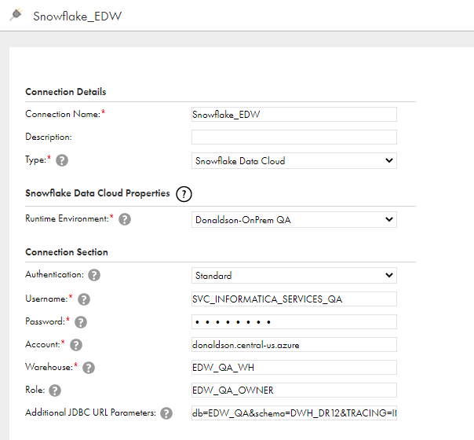

*The last field ‘Additional JDBC URL Parameters’ must contain values for QA as below:

db=EDW_QA&schema=DWH_DR12&TRACING=INFO&CLIENT_SESSION_KEEP_ALIVE​=TRUE&CLIENT_MEMORY_LIMIT=7000&CLIENT_METADATA_REQUEST_USE_CONNECTION_CTX=TRUE&CLIENT_ENABLE_CONSERVATIVE_MEMORY_USAGE=FALSE

Oracle:

[**ORA_R1213**](javascript:doView('011AUZ0B000000000009',%20'ORA_R1213'))

Settings must be like:

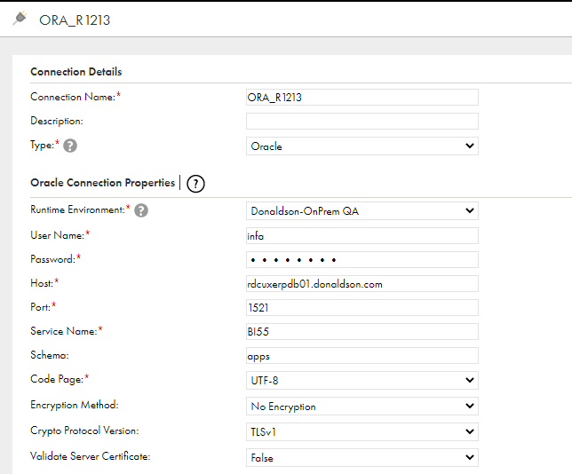

Rest of fields maintain in blank.

# Deployment of agent files (i.e, DEV to QA)

## Introduction

Once DEV and QA agents are installed (review this on ‘how to: agent’ documentation) used/created folders, files and scripts must be deployed from DEV to QA (those folders, files and scripts is not the ones that emerges on agent installation, but the ones created by users, in example: parameter folders/files).

## Step 1

From DEV to QA agent, some folder/files was migrated. On /INFA_SHARED directory, folders migrated was:

LkpFiles - /INFA_SHARED/LkpFiles

SCRIPTS - /INFA_SHARED/ SCRIPTS

SrcFiles - /INFA_SHARED/SrcFiles

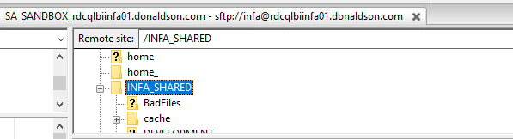

Commands used to export folders and all inside it in .zip format from DEV, and then extract on QA.

Once you log in the source agent at putty:

cd /INFA_SHARED (this command will bring you to /INFA_SHARED directory on the agent you’re logged in on putty).



Now you must use command below for all folders you have to download from source agent (i.e, DEV agent).

tar -cvf SCRIPTS.tar SCRIPTS (this command zips the folder and creates a new file with .tar at the end of its name)

after running command above, you must download the zip folder to your machine.

Once downloaded, log into filezilla at TARGET (QA) Agent, and drag the zip file into /INFA_SHARED

After doing that, must log in TARGET agent (i.e, QA agent) on putty and run:

cd /INFA_SHARED (this command will bring you to /INFA_SHARED directory on the agent you’re logged in on putty).

After that, you must unzip the folder you downloaded by command below.

tar -xvf SCRIPTS.tar (this command extracts the .tar file)

Once you did this for folder SCRIPTS in the example, this folder will now be on /INFA_SHARED directory of QA agent, just as the same folder as DEV.

Must do that for every folder mentioned above.

After doing that, run command below to set permissions, so IICS can run everything inside it, such as scripts and files.

chmod 755 -R /INFA_SHARED (this command gives permission to execute for everything under the /INFA_SHARED directory).

## Step 2

The bash.profile file, on QA agent, at the path /home/infa/.bash_profile must have all oracle variables set to QA:

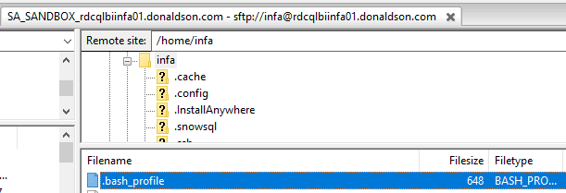

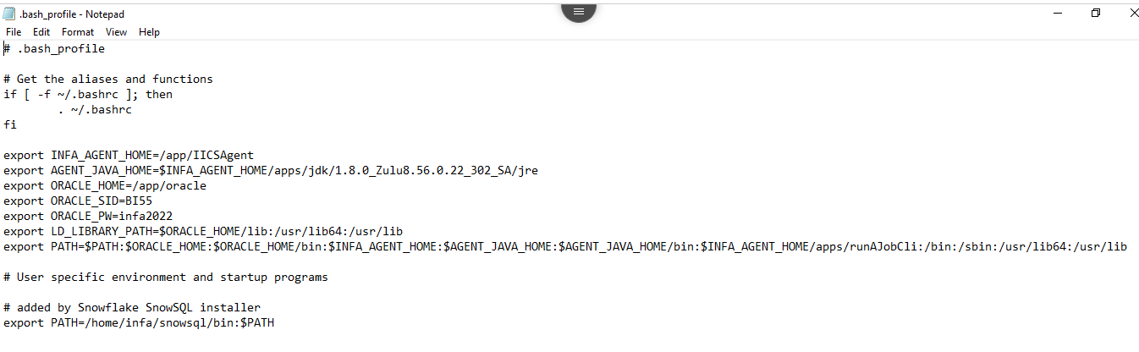

export INFA_AGENT_HOME=/app/IICSAgent

export AGENT_JAVA_HOME=$INFA_AGENT_HOME/apps/jdk/1.8.0_Zulu8.56.0.22_302_SA/jre

export ORACLE_HOME=/app/oracle

export ORACLE_SID=BI55

export ORACLE_PW=infa2022

export LD_LIBRARY_PATH=$ORACLE_HOME/lib:/usr/lib64:/usr/lib

export PATH=$PATH:$ORACLE_HOME:$ORACLE_HOME/bin:$INFA_AGENT_HOME:$AGENT_JAVA_HOME:$AGENT_JAVA_HOME/bin:$INFA_AGENT_HOME/apps/runAJobCli:/bin:/sbin:/usr/lib64:/usr/lib

## Step 3

tnsnames file must have oracle QA (BI55) database connection added, file path for file on agent is /app/oracle/network/admin

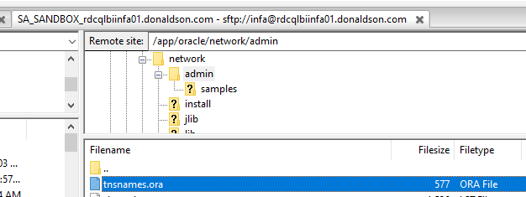

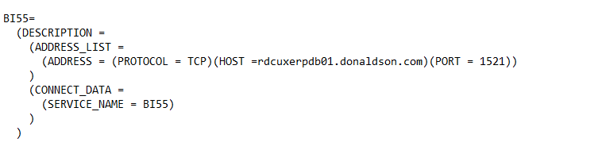

BI55=

(DESCRIPTION =

(ADDRESS_LIST =

(ADDRESS = (PROTOCOL = TCP)(HOST =rdcuxerpdb01.donaldson.com)(PORT = 1521))

)

(CONNECT_DATA =

(SERVICE_NAME = BI55)

)

)

# SnowSQL

SnowSql must be installed on QA agent, and pointed to QA snowflake environment.

Jeremy Brooks from RPA team along with Robert Barnes, did the SnowSql installation work on QA agent. Jeremy shared links he used, which has steps on this installation .

<https://community.snowflake.com/s/article/How-to-Install-Snowsql-in-the-new-directory-in-Linux>

<https://docs.snowflake.com/en/user-guide/snowsql-install-config.html>